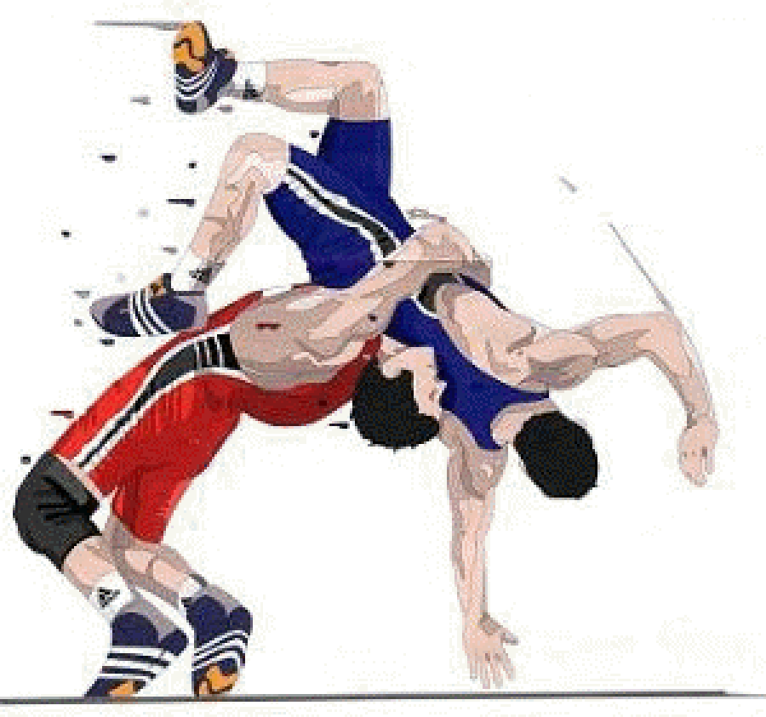 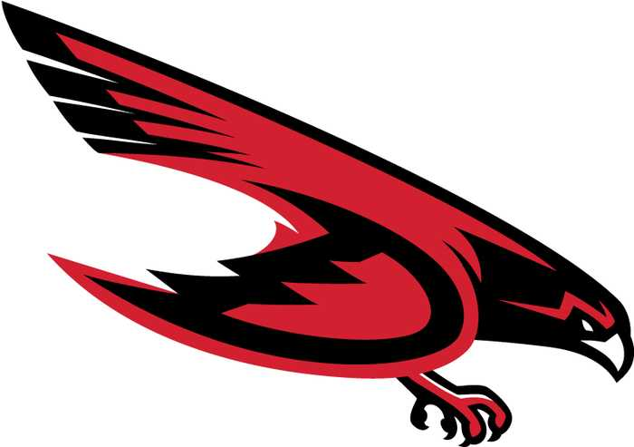

**2024 DUNEDIN FALCONS**

**GIRLS Wrestling Schedule**

**HEAD COACH: ALEX LEHBAR**

|  |  |  |  |
| --- | --- | --- | --- |
| **Date** | **Home/Away** | **Opponent** | **Event Location** |
| 11/21/2024 | AWAY | SCRAMBLE | COUNTRYSIDE |
| 12/7/2024 | AWAY | LET FREEDOM RING | FREEDOM HS |
| 12/10/2024 | HOME | BOCA CIEGA, EAST LAKE, P. PARK | DUNEDIN |
| 12/11/2024 | AWAY | IBT WIREGRASS RANCH | WIREGRASS RANCH |
| 12/14/2024 | AWAY | COUGAR CLASH | COUNTRYSIDE |
| 1/11/2025 | AWAY | IBT WIREGRASS RANCH | WIREGRASS RANCH |
| 1/17/2025 | AWAY | LADY LONGHORN | HARMONY HIGH SCHOOL |
| 2/15/2025 | TBD | DISTRICTS | TBD |
| 2/21-22/2025 | TBD | REGIONALS | TBD |